To prepare sulphur dioxide gas and study its physical and chemical properties.

Materials Required: Copper turnings, conc. sulphuric acid, dil. sulphuric acid, potassium permanganate solution (Purple solution), potassium dichromate solution (Transparent Orange solution), red and blue litmus papers, a round bottom flask, a thistle funnel, a delivery tube, a double bored cork, a piece of card board as a lid, a laboratory stand, a burner, a wire gauze, a tripod stand, two test tubes, a trough, a measuring cylinder (50 mL) and 5ml, R.B. stand, spatula and two gas jars.
Experimental Procedure:

- Take a round bottom flask, clap the round bottom as shown in figure.

- Place few pieces of copper turnings (about 5 g) in a round bottom flask using spatula.

- Place a double bored cork on the mouth of the round bottom flask.

- Insert of the thistle funnel through one of the holes of the cork and insert a delivery tube to another hole of the cork.

- And connect the delivery tube to the gas jar as shown.
- Gently add 15 - 20 mL of conc. sulphuric acid to it through a thistle funnel using a measuring cylinder.
- Heat the contents gently as the gas formation starts after sometime.
- Collect the gas in the gas jar and study its properties as per the steps given in the observation table.
Test | experiment | Observation | Inference
- Physical Properties
- colour | Look at the sulphur dioxide filled  gas jar. | Colourless
- Solubility in water | Take a gas jar filled with sulphur  dioxide with its mouth closed  with a lid. Invert it in water  contained in a trough. Remove  the lid carefully. | Soluble in water
- Chemical properties
- Acidic or basic  nature | Insert damp or wet litmus paper  in the jar filled with sulphur  dioxide. | Moist Red litmus has no changes  Moist blue litmus changes to red. | - SO₂ dissolves in water to form sulphurous acid due to which it possesses an acidic character.  H₂O + SO₂ → H₂SO₃
- Reaction with potassium permanganate solution | Take about 2 mL of potassium  permanganate solution in a test  tube, add about 1 mL of dilute  H2SO4 and pass sulphur dioxide  gas in this solution. | The purple colour of the potassium permanganate changes to colourless when SO2 gas is passed. | 5SO2 + 2KMNO4 + 2H2O = 2H2SS3 + 2MNSO4 + K2SO4.  Sulphur dioxide being a strong reducing agent, reduces the purple coloured solution to form a colourless solution .
- Reaction with potassium dichromate solution | Pass sulphur dioxide through  another test tube containing  2ml acidified potassium dichromate  solution and 1ml of H2SO4 | The orange colour of the potassium dichromate changes to green | Sulfur dioxide react with potassium dichromate and sulfuric acid to produce potassium sulfate, chromium(III) sulfate and water and the solution turns from orange to green.
 |  |  | SO2​+K2​Cr2​O7​+3H2​SO4​→K2​SO4​+Cr2​(SO4​)3​+3H2​O

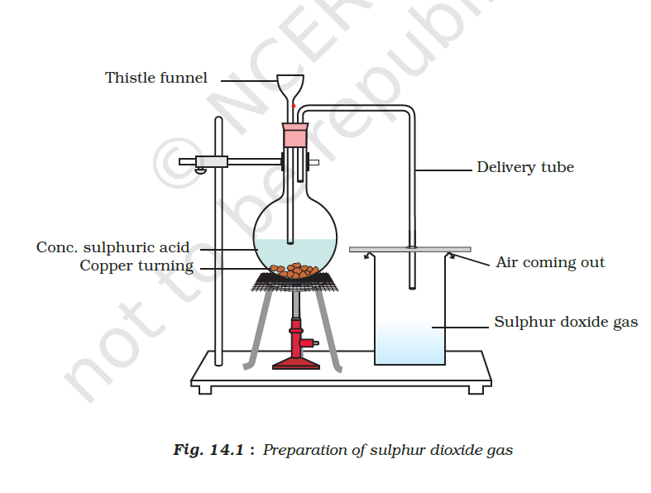
Ref: https://www.youtube.com/watch?v=x7GycA9_wKg (Please check the video for the set up.)
